U2 Generator CCW
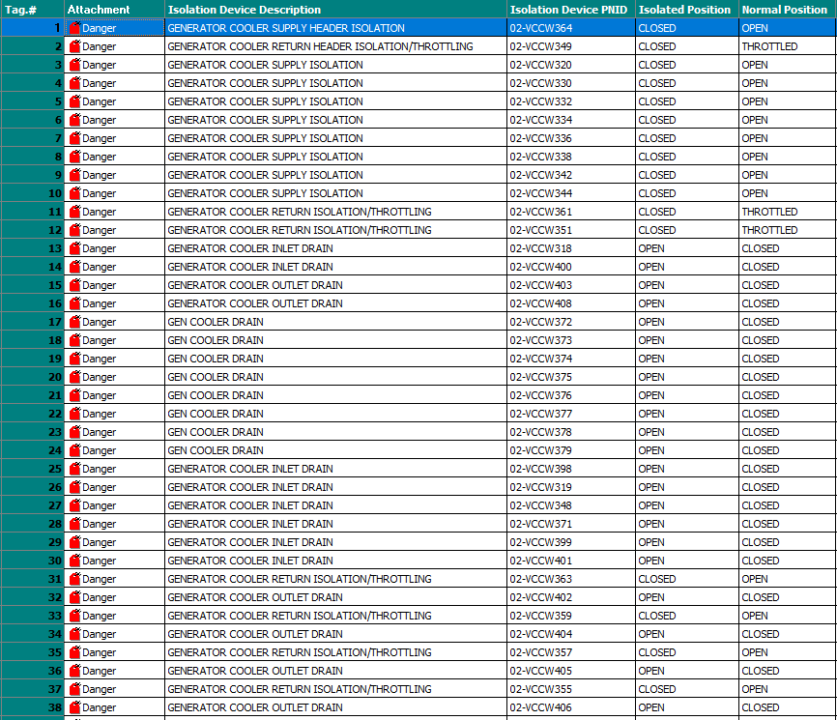
Unit 2 Generator
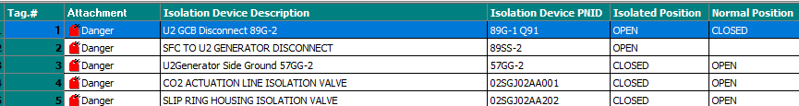

Unit 2 GSU
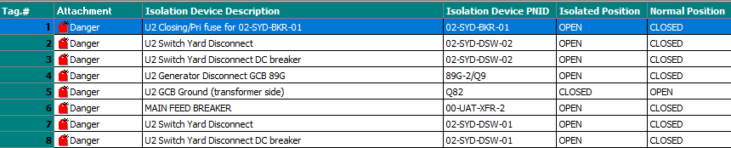
Unit 2 Seal Oil
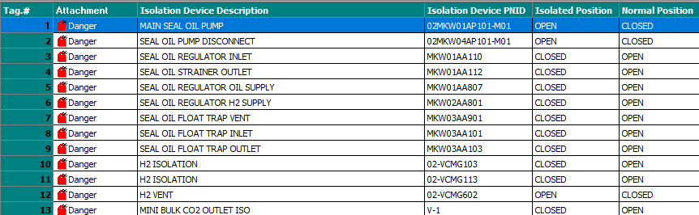
Unit 2 Lube oil
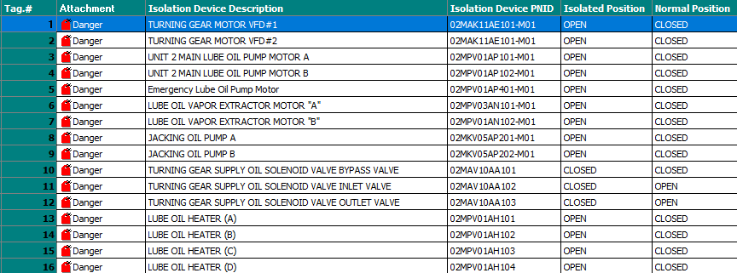
Unit 2 Control oil
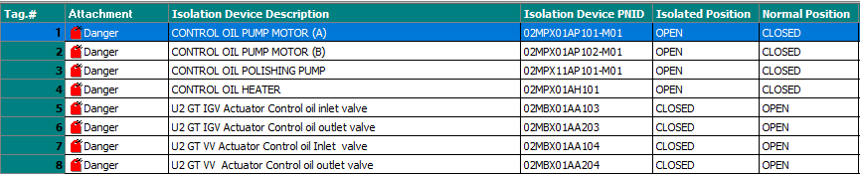
Unit 2 Waterside
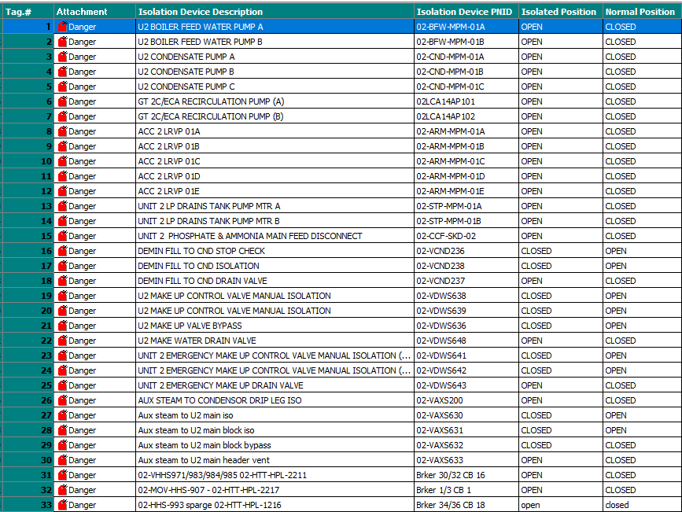
U2 Fuel gas performance heater flow meter
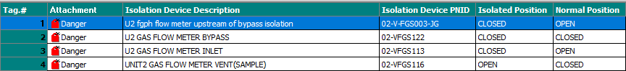
U2 CO2 fire protection

Unit 2 Fireside (2024)
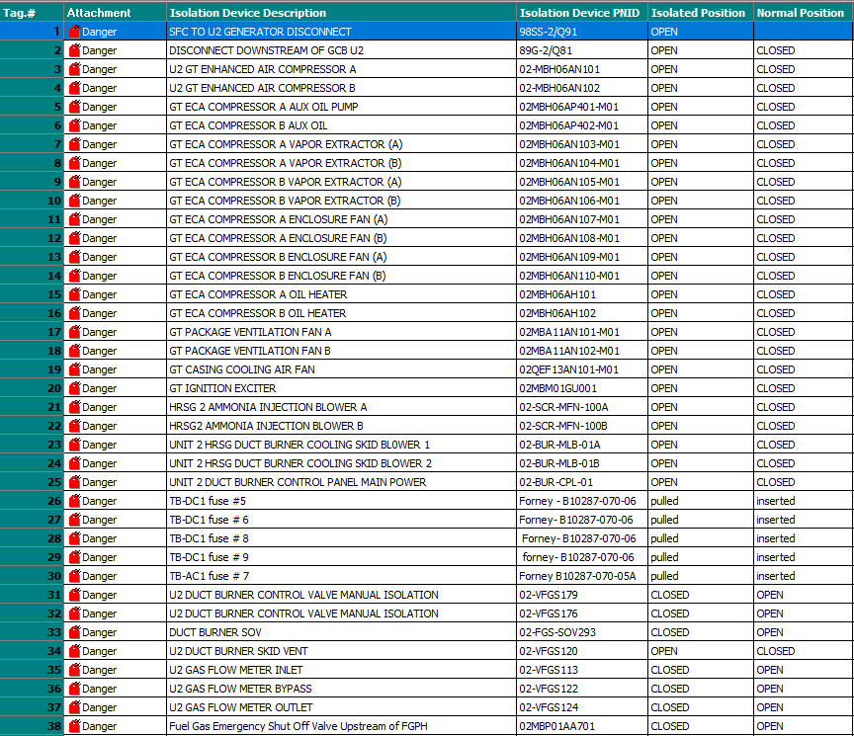
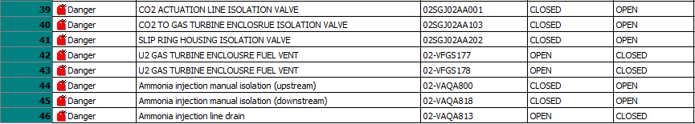
Unit 2 IGV/VV Calibration
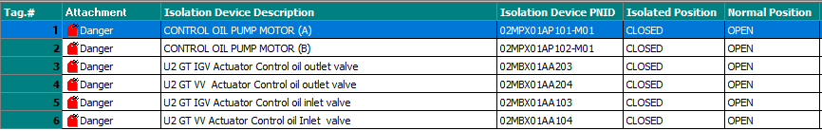
Unit 2 GSU AND COMED Outage
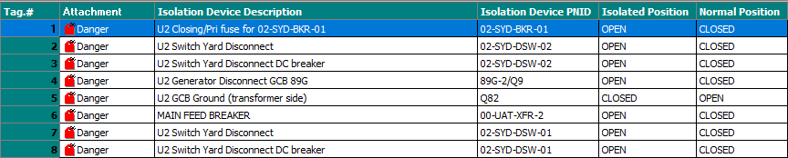
Unit 2 UPS System Annual PM
Unit 2 TCP Rectifier
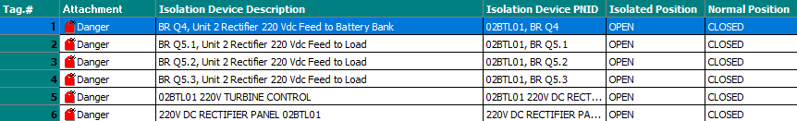
Unit 2 Helen strainer
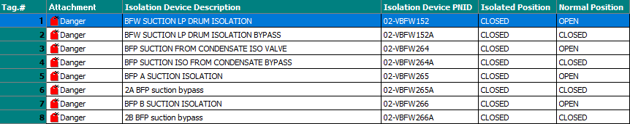
Unit 2 Calcite contactor
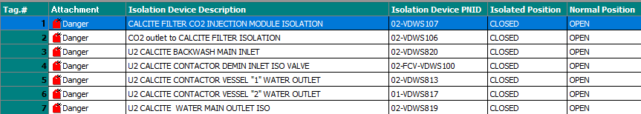

Unit 2 ST building fire system water supply
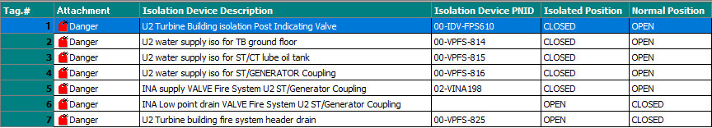
Unit 2 LRVP Alpha
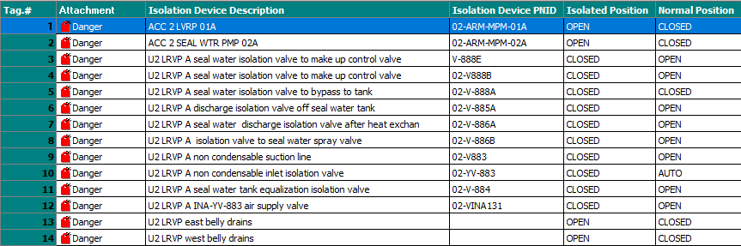
Unit 2 LRVP Bravo
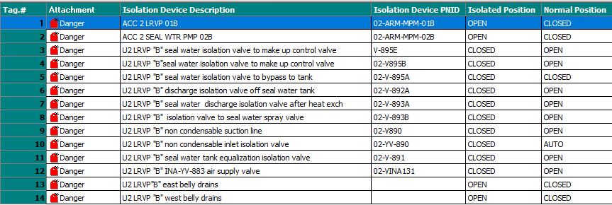

Unit 2 LRVP Charlie
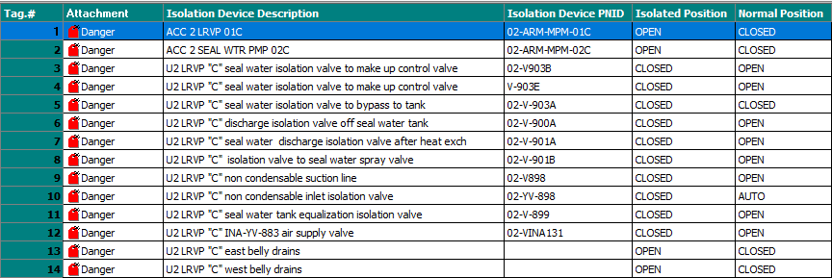
Unit 2 LRVP Delta
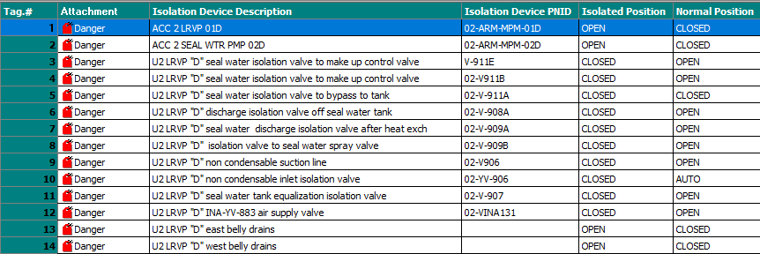
Unit 2 LRVP Echo
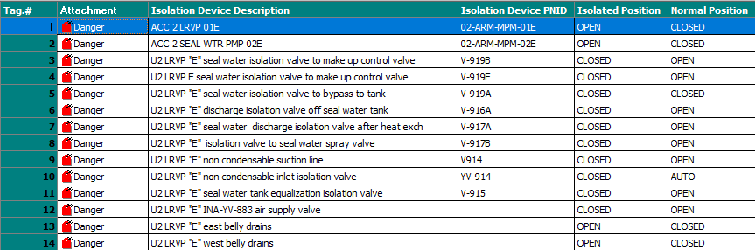

Unit 2 Turning Gear (2026)
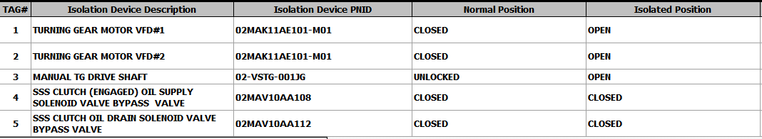
Unit 2 Ignitor 2026
Unit 2 CCW ACHE fans (2026)
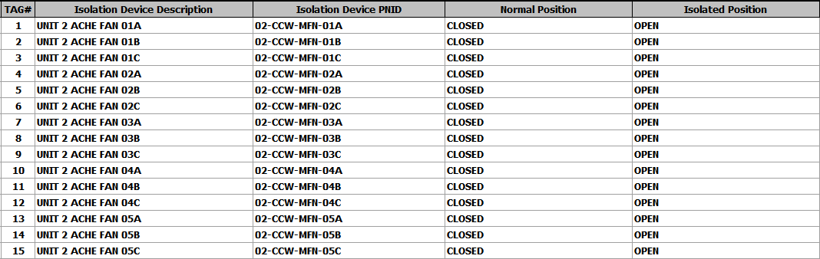
Unit 2 Air bowl Regulators
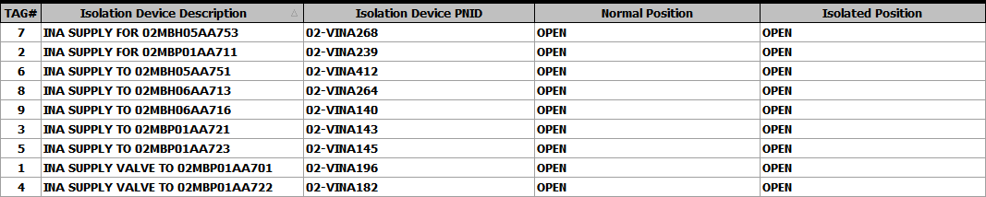

Unit 1 CCW ACHE fans (2026)
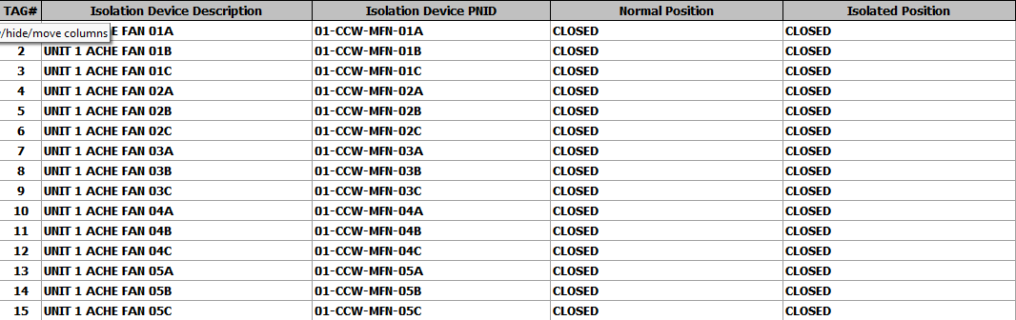
Unit 1 Turning Gear
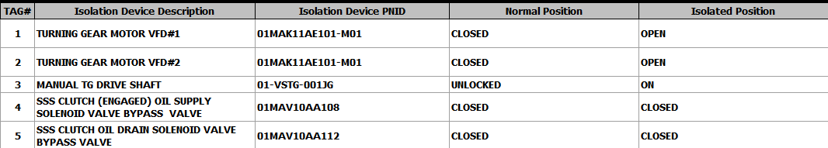

Unit 1 Seal oil (2026)
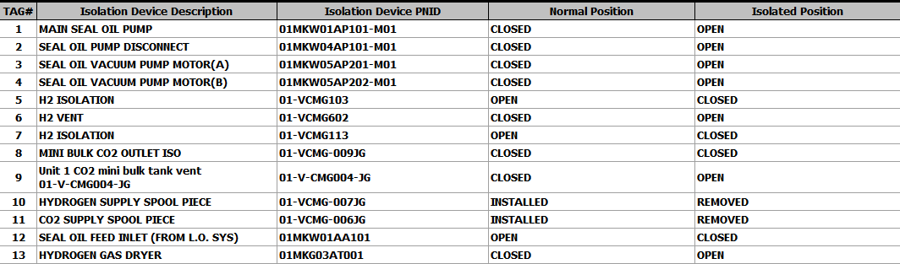
Unit 1 Lube oil (2026)
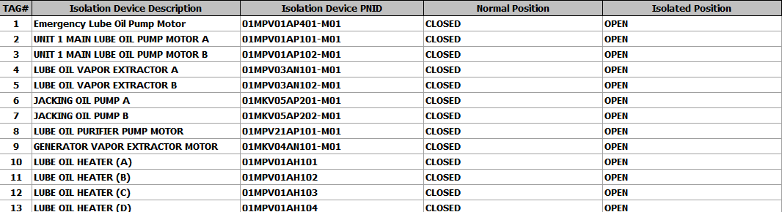
Unit 1 Control Oil
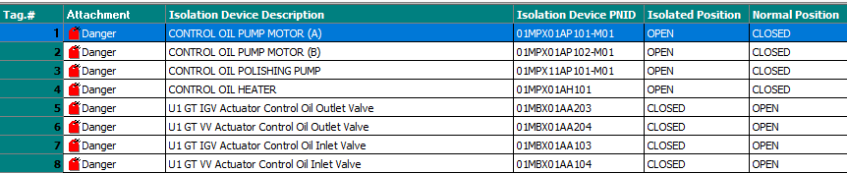

Unit 1 CO2 Fire System
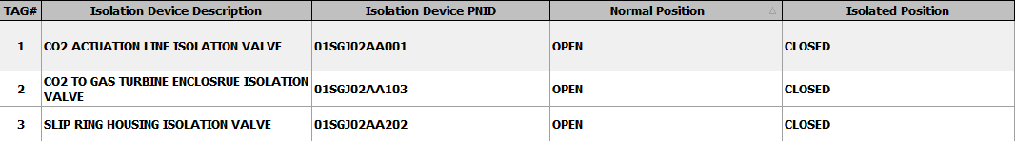

Unit 1 Helen strainer
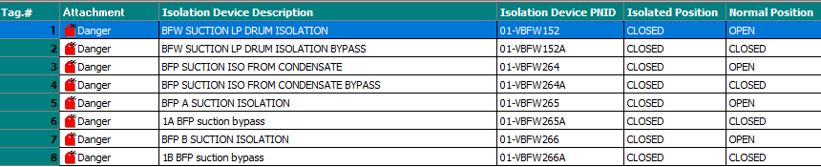
Unit 1 Air Bowl Regulators
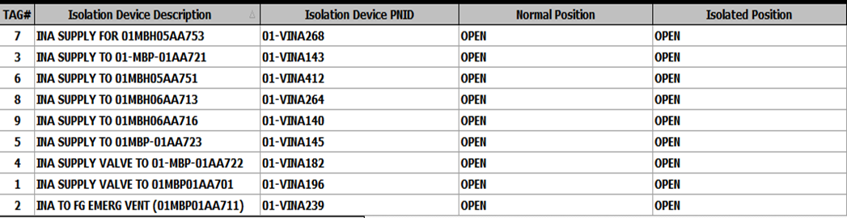
Unit 1 Generator
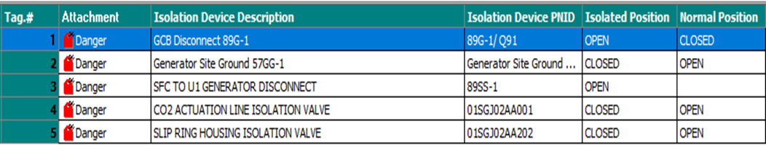

Unit 1 Fireside
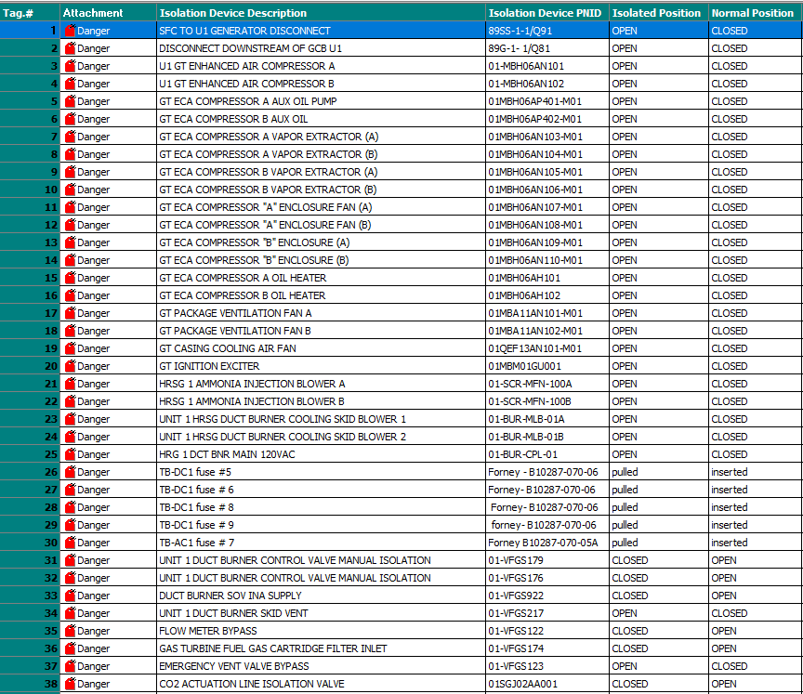
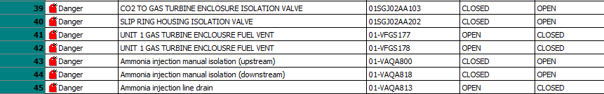

Unit 1 Waterside
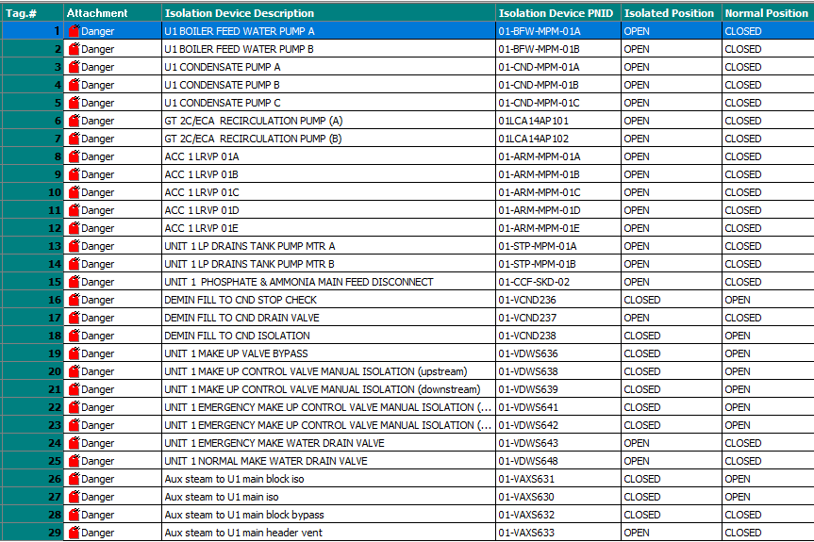
Unit 1 GSU
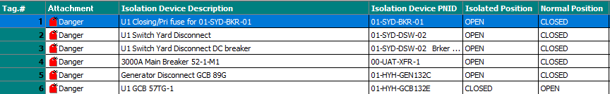

Unit 1 LRVP Alpha
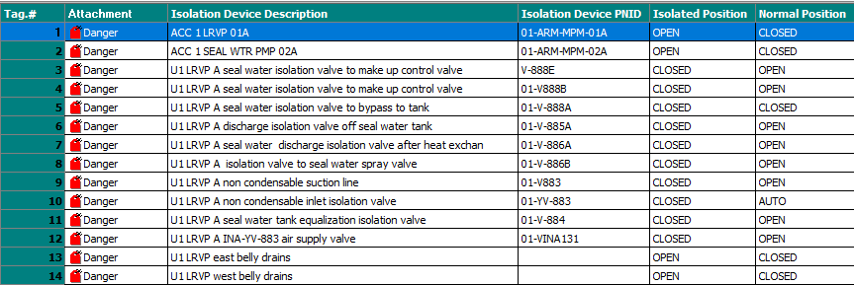
Unit 1 LRVP Bravo
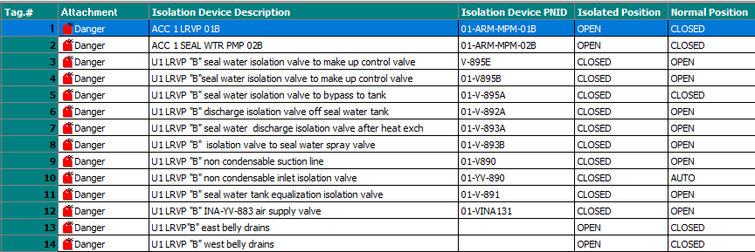
Unit 1 LRVP Charlie
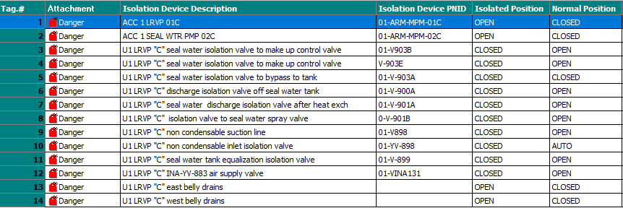
Unit 1 LRVP Delta
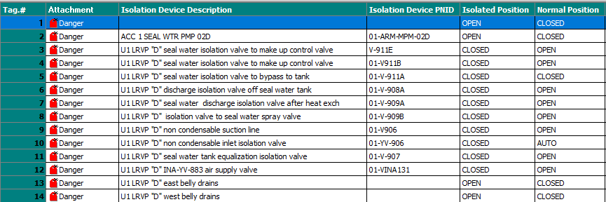
Unit 1 LRVP Echo
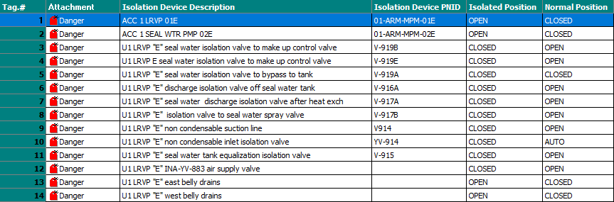
U1 Fuel gas performance heater flow meter
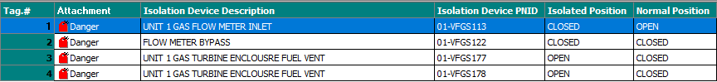

BOP Air Compressor Alpha
Air Compressor Bravo

